Recycling Lab
Name
Institution of Affiliation
Recycling Lab
Introduction
Waste is considered as material that are no longer needed and therefore subsequently disposed. Due to the increasing waste disposal, it is impeccable that waste be well managed. Besides management and source reduction, it is important to investigate the type of waste management including waste containers, management practice, type of wastes and possible sources. The purpose of this lab was therefore to investigate this waste management practices at local buildings.
Table
Location | Waste Item | Type of Waste | Disposable Status | Reusable Alteranative?
Room 46, next to the door second floor | Bin | Papers, food stuff | Good | No
Room 200, north window next to the door third floor. | Plastic bag | Plastics bags, papers, food , | Not good | No
Room 401, next the main door | Plastic bin | Shredded papers, office equipment, printing papers | Not good. Not well covered. | No
Outside Room 21 first floor at the corner of the building | Large plastic bin | Papers, plastic cans, food cans, plastic papers, | Not well managed, bin overflowing | No
Room 128, next to the southwest window, second floor | Large plastic bin | Office papers | Well maintained, clean and not full | Yes

One step that can be employed by IHCC to prevent waste through source reduction is generating products that have a longer lifespan. The longer lifespan will help in source reduction since there will fewer waste products that will be available (Muralikrishna & Manickam, 2017). Similarly, promoting the use of reusable containers is an effective step in controlling the source of waste materials because a significant proportion of the containers can be reused instead of disposal (Muralikrishna & Manickam, 2017). The third step that can be employed to prevent waste through source reduction is recycling of the waste materials. The recycling process will minimize the volume of wastes from the source (Muralikrishna & Manickam, 2017).
The recyclables have been found in the trash bins and the recycling bins. The reason attributed to disposal of recyclables in trash bins and recycling bins is due to ineffective communication on the appropriate treatment of recyclables instead of disposing them in trash bins.
The contamination of the trash in trash and recycling bins is an issue since it has an adverse effect on the recycling rates. Contaminated recyclables have a higher potential of been rejected by recyclers and disposed in landfill that results to wasted recycling endeavors since it become impossible due to increased costs (Rachelson, 2017).
Contamination of recycling and trash bins can be prevented by employing effective communication in an organization, placing the recycling bins in strategic locations for ease of disposal, and emptying and rinsing the containers (Rachelson, 2017).

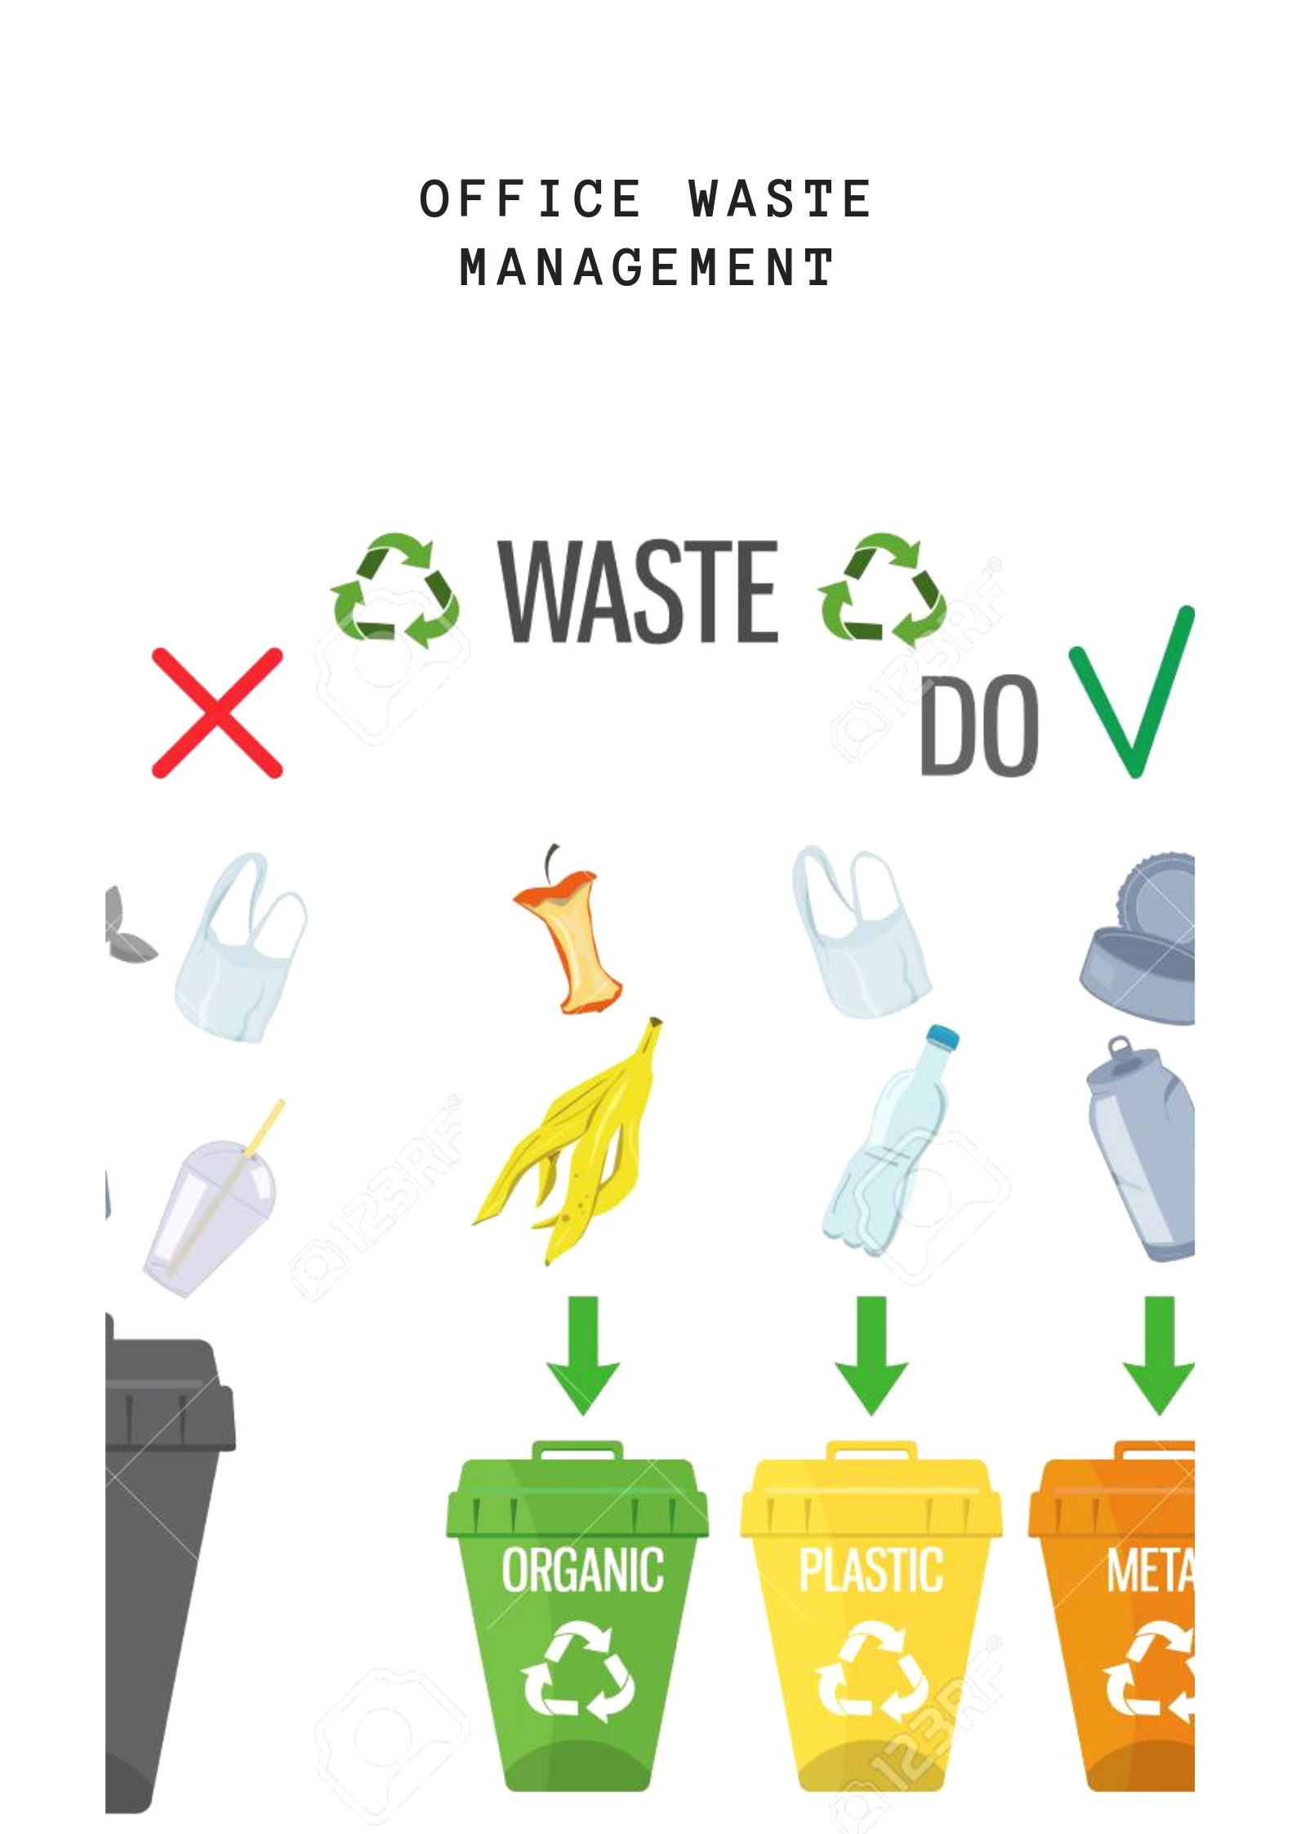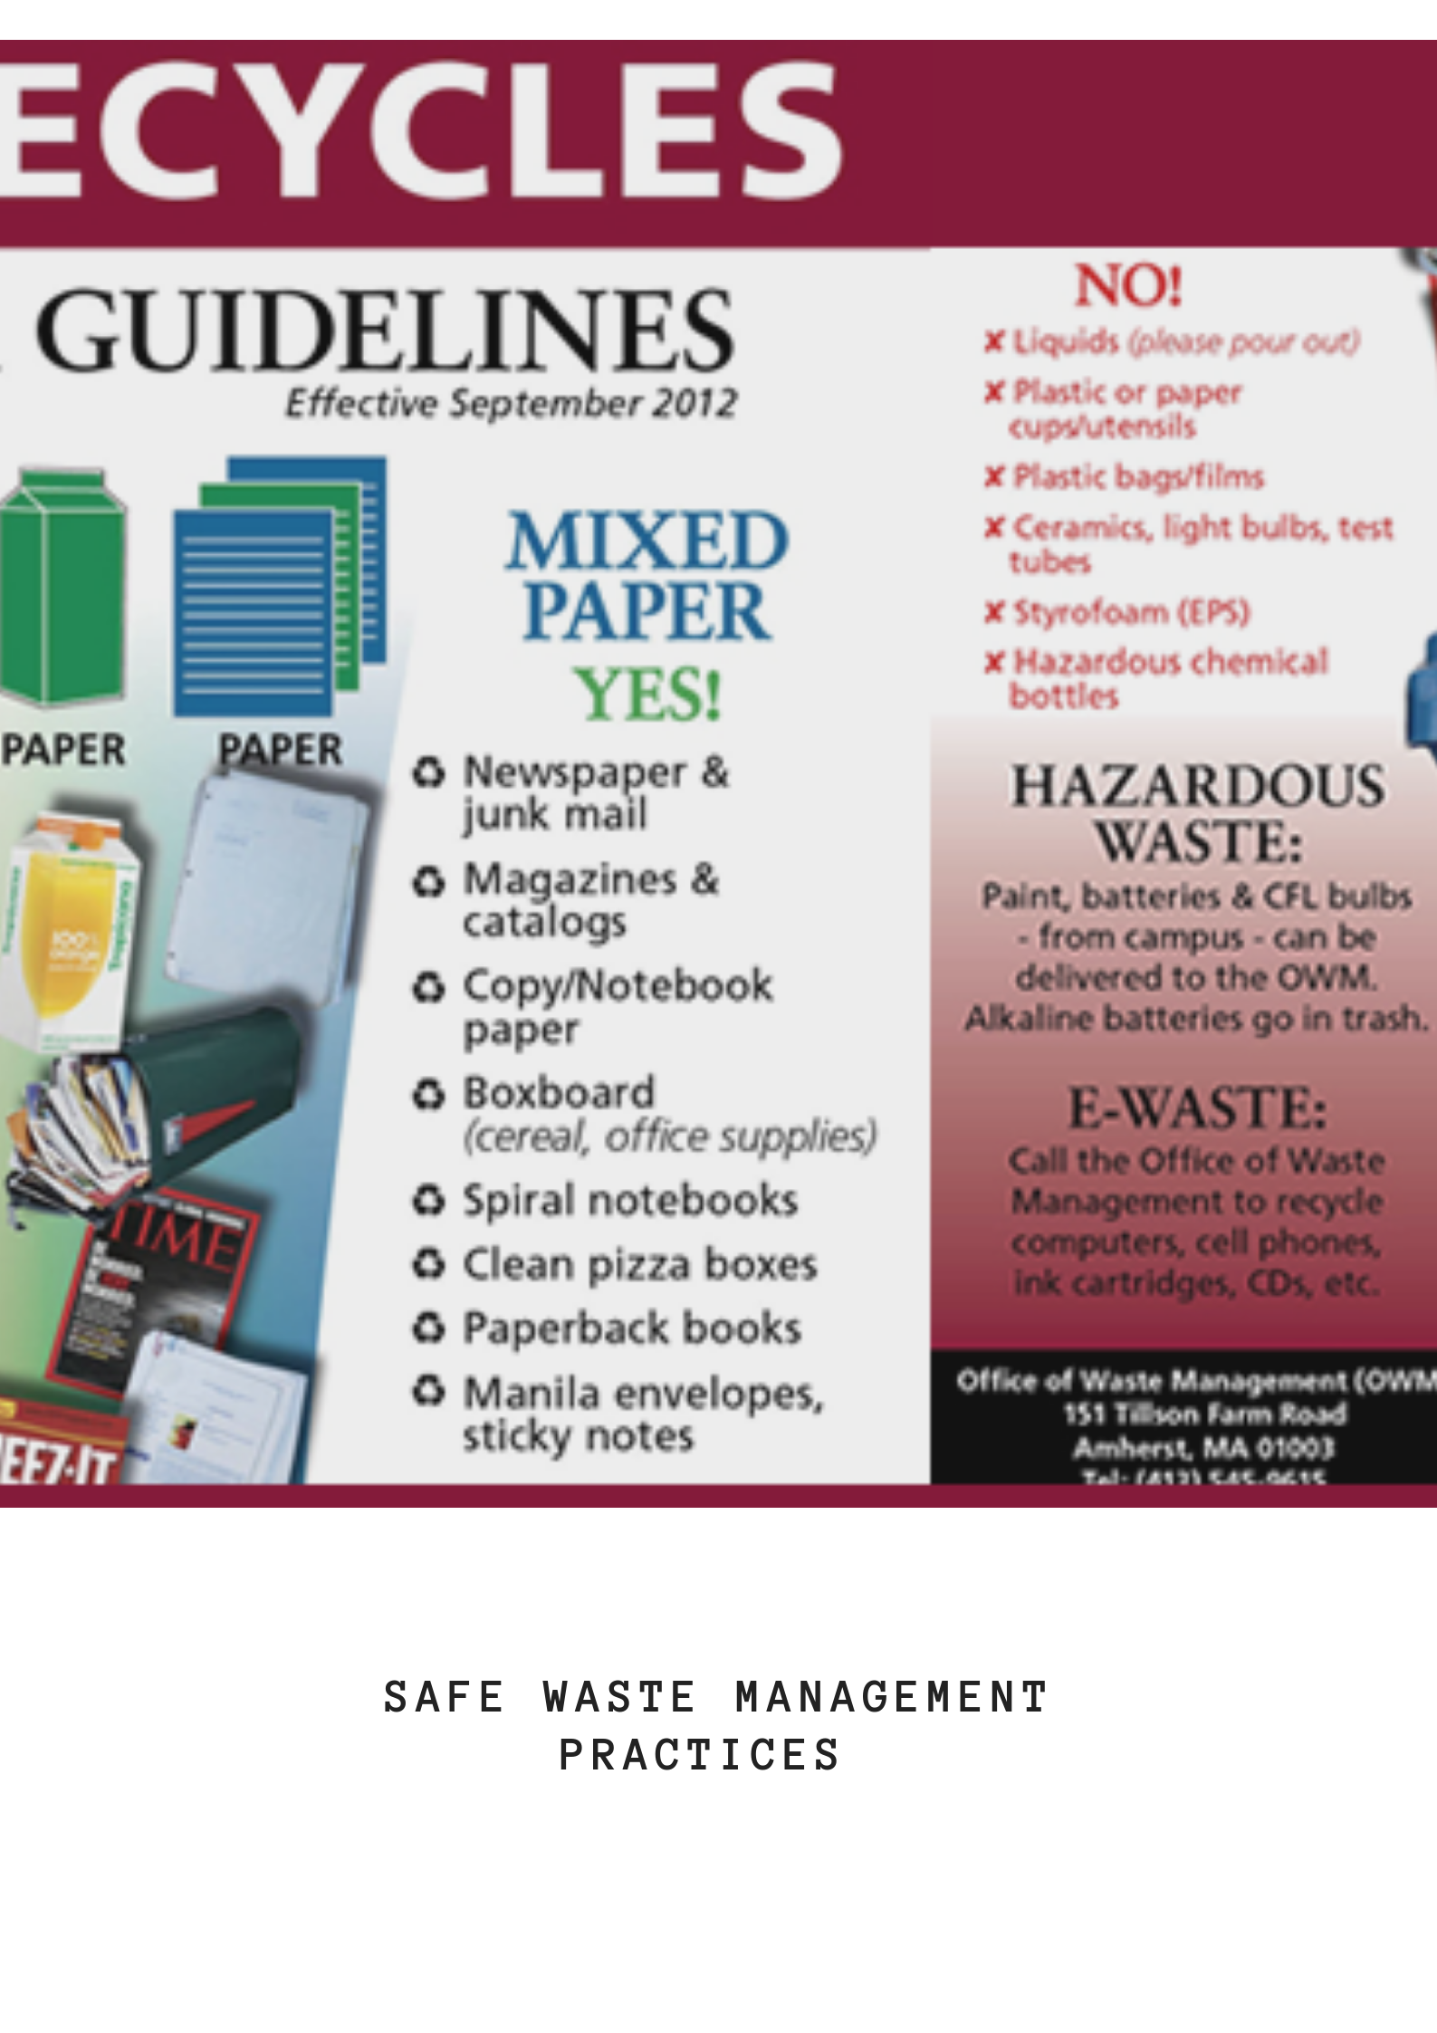
References
Muralikrishna, I. V., & Manickam, V. (2017). Solid Waste Management. Retrieved 2019, from https://www.sciencedirect.com/topics/earth-and-planetary-sciences/source-reduction
Rachelson, D. (2017). What is Recycling Contamination, and Why Does it Matter? Retrieved 2019, from https://www.rubiconglobal.com/blog-recycling-contamination/

